VIETNAM NATIONAL UNIVERSITY OF HOCHIMINH CITY

THE INTERNATIONAL UNIVERSITY

SCHOOL OF COMPUTER SCIENCE AND ENGINEERING



MERN STACK WITH GRAPHQL FOR SHARE ACCOMODATION APPLICATION

**Advisor: MSc. Dao Tran Hoang Chau**

**Student name: Le Nguyen Nhat Minh**

A thesis submitted to the School of Computer Science and Engineering

in partial fulfillment of the requirements for the degree of   
Bachelor of Information Technology

Ho Chi Minh City, Vietnam

2021

MERN STACK WITH GRAPHQL FOR SHARE ACCOMODATION WEB APPLICATION

APPROVED BY APPROVED BY COMMITTEE

________________________________ ________________________________

**Dao Tran Hoang Chau, MSc**

________________________________

**THESIS COMMITTEE**

# ACKNOWLEGMENTS

During the period of challenging time with Thesis. With a sincere heart, I would like to say thanks to my supervisor MSc. Dao Tran Hoang Chau, who directly guided me and to be always willing answered my questions, instructed me handle with complex problems as well as support me various precious ideas in the case of extending my Thesis.

In the process of studying, I’m also grateful Dr. Tran Thanh Tung for supporting technical implementation and suggestions. Furthermore, I really appreciate teachers in Computer Science and Engineering Department for enthusiastically conveying deep knowledge, advices to student.

Finally, I would like to thank my friends at International University for encouragement and help me in the process of doing thesis project.

# TABLE OF CONTENTS

ACKNOWLEGMENTS

TABLE OF CONTENTS

LIST OF FIGURES

LIST OF TABLES

CHAPTER 1 INTRODUCTION

1.1 Motivation

1.2 Problem Statement

1.3 Scope and Objectives

1.4 Assumption

CHAPTER 2 TECHNOLOGIES

2.1 Background of query standards

2.1.1 REST

2.1.2 GraphQL

2.2 GraphQL Architecture

2.2.1 Simple architecture

2.2.2 Existing systems

2.2.3 Hybrid systems

2.3 The contrast of GraphQL and REST Architecture

2.4 Overview of MERN stack

2.4.1 MongoDB

2.4.2 Express

2.4.3 ReactJS

2.4.4.Node.js

2.5 Other Technologies

2.5.1 Apollo

2.5.1.1 Apollo Server

2.5.1.2 Apollo Client

2.5.2 JSON Web Tokens

Chapter 3 METHODOLOGY

3.1 Functional Requirement

Chapter 4 SYSTEM DESIGN

4.1 How the system work

4.2 Frontend client

4.2.1 React Core Architecture

4.2.1.1 DOM vs Virtual DOM

4.2.1.2 Reusable Components

4.2.1.3 React Hooks

4.2.2 Apollo Client

4.2.2.1

# LIST OF ABBREVIATIONSALS

REST Representational State Transfer

API Application Programming Interface

URL Uniform Resource Locator

HTTP Hypertext Transfer Protocol

JSON JavaScript Object Notation

IDE Integrated Development Environment

SDL Schema Definition Language

CRUD Create, Read, Update, and Delete

UI User Interface

SPA Single-page Application

# ABSTRACT

In the modern world, office, factory or school often focus on the industry zone or in the big cities. However, not everyone also lives in these areas. Most of them come from the rural areas or very far away from the workplace. In addition, some of them are just alone, their budget may be also limit for spending on renting an apartment, house or even room. Furthermore, migration from other places, they have quite troubles in finding a place for livings. Base on that demand, share accommodation website has been released to adapt these requirements.

However, there are few available websites in Vietnam focus on that problems. Almost, these websites mainly provide rental apartments, houses or rooms and lack of share accommodation. Moreover, those websites are now built rudimentarily and have some limitations in common case such as bottle-neck, poor interactions or overloading due to some weak aspects of REST. For that reasons, GraphQL is applied to this thesis to solve these issues, boost performance and make the interaction between server and client become less complicated. Moreover, MERN stack is powerful and effective to work with GraphQL.

# CHAPTER 1 INTRODUCTION

* 1. Motivation

The Share Accommodation is simple way to explain that house owners share their home with other renters to reduce rental fees. In the share accommodation application, users are permitted to find renters who are registered to search a house or an apartment. Also, renters can find available houses or apartments which is posted for sharing.

In addition, GraphQL is applied to this application to resolve RESTful API limitation and boost performance higher.

* 1. Problem Statement

In the present time, there are very few websites focus on the house share or flatmate finder. However, these websites were almost built very basic and show less information or even just a static web. Moreover, they have troubles when receive tons of submitting request at the same time lead to be overloaded or died. Although microservices was born to resolve these problems, this type of project is not big enough to use microservices in order to scale server. That is the reason why GraphQL is used to point out the limit aspect of REST.

* 1. Scope and Objectives

The problem of RESTful API is that they load too much data without necessary purposes. Therefore, I use new technologies to tackle that weakness of REST and be able to develop bigger in the future through different levels such as:

* Web(client), Server(backend) and GraphQL(query language).
* Web: ReactJS is a strong javascript library for creating interactive UIs. It functionally updates and change data with rendering right components. Besides, friendly view design make code cleaner.
* Server: NodeJS work as non-blocking I/O to develop scalable network application and its ability can handle a huge amount of concurrent operations.
* GraphQL: A query language for APIs was developed by Facebook permits clients the power to request what data they need and nothing more.
  1. Assumption

Due to the barrier of time and complex of the issues, the thesis has not been absolute done. It need to be improvement and development in the future. Some of features in the list of function is not ensured to complete. However, I would like to list several assumptions that may finish later:

* Landlord: a specified page for house owner to manage their member. It has still not built now. In final product, it might be added to make the app more interactive.
* Dashboard: there are a lot chart in order to analyze user behavior built. However, it seems to be need more chart to visualize data in details

# CHAPTER 2 TECHNOLOGIES

This chapter will cover basic background of technologies are used in the thesis project.

**2.1 Background of query standards**

In the technology world, a wide variety of query standards that apply to various environments such as SQL (Structured Query Language), Graph Query Language, REST (Representational State Transfer) and more flexible others.

2.1.1 REST

Representational State Transfer or REST which was first introduced in 2000 by R.F (Roy Fielding). REST become popular in the next year due to its architectural concept which support to design distributed systems. REST is a much lighter and high performance compared with SOAP (commonly used at that time). Noticeably, REST was born to solve problems about bandwidths that SOAP could not handle.

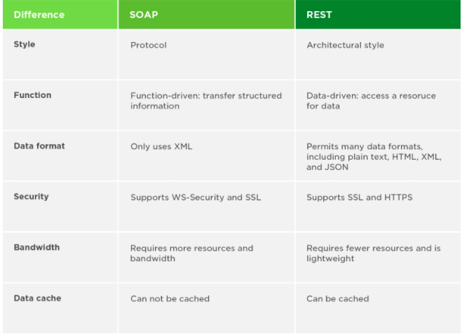

Figure 1 SOAP vs. REST: The key differences (By Upwork Staff, 2017)

2.1.2 GraphQL

In GraphQL, it was released in the recently by Facebook in 2015 and officially open source in 2018. They wanted to find a solution to deal with the increasing of mobile applications. Because of the weakness of mobile devices, they are actually hard for loading a heavy website as Facebook. Fetching multiple queries to do a task being really wasted. Consequently, they developed GraphQL to wrap all data needed into a single query. Thus, performance is improved significantly.

**2.2 GraphQL Architecture**

As mentioned above, GraphQL is a query language for API as well as a server-side runtime in order to execute queries based on a type system defined by programmer. This technology also decreases complicated logics to restructure the data after executing multiple fetches.

2.2.1 Standard Architecture

The simple architecture between client and a server that implements the GraphQL. As a query arrives., the server reads the query’s payload and get the essential information from database

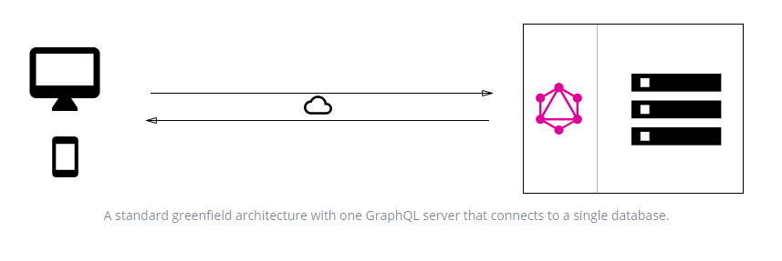

Figure 2 A common client-server architecture with GraphQL

(howtographql, 2021)

Then, it will return the response object which is constructed as the response format to the client. Noticeably, GraphQL runs as transport-layer agnostic means that it is able to be used with another network protocol such as TCP, WebSockets, etc…. Moreover, GraphQL was designed flexibly to handle with any database such as SQL (PostgreSQL), NoSQL (MongoDB).

2.2.2 In Case of Existing Systems

One of powerful GraphQL is the integration of multiple existing systems. That’s quite great for many companies with legacy infrastructures and APIs that have developed for long years and require maintenance now. However, it is hard for these companies to connect multiple systems. In that case, GraphQL is an amazing choice to unify these existing systems without considering their complexity.

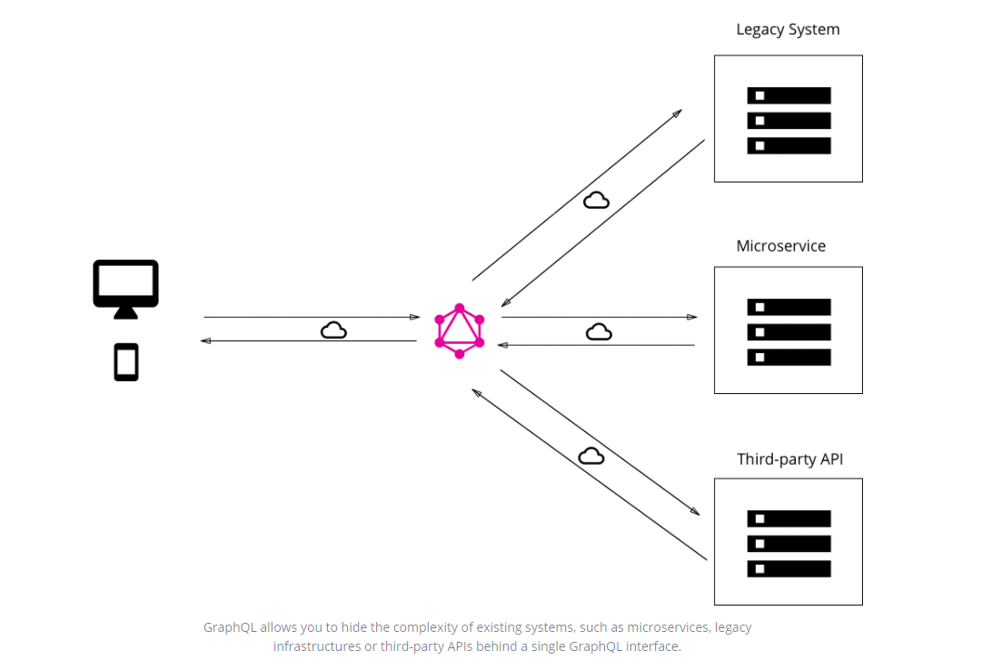

Figure 3 GraphQL as a gateway for existing systems (howtographql, 2021)

As the same previous architecture, the GraphQL server just does its work that receives query from client, then wraps data fetching from existing systems in GraphQL response format and response to client.

2.2.3 Hybrid Architecture

In this architecture, the GraphQL server plays a centre gate way as primary end point in the centre of the system.

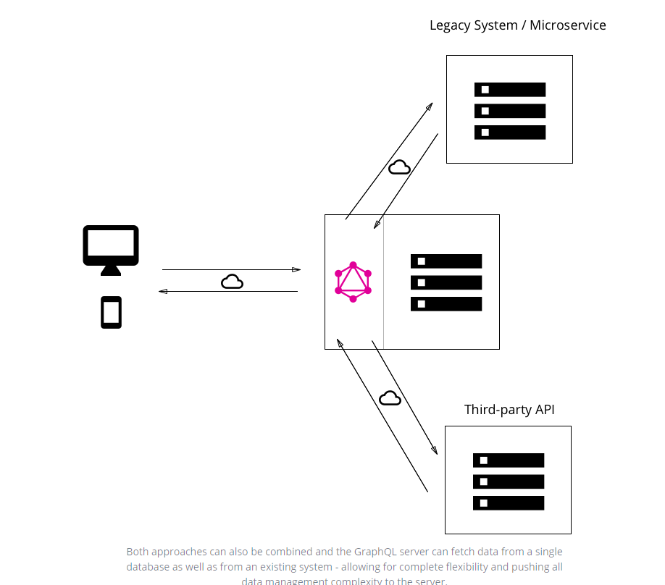

Figure 4 Hybrid GraphQL architecture (howtographql, 2021)

This API bridge directly accesses to database as a basic first version. A query is received by the server, then it response either to database connected or some of the system integration after resolve that query.

2.3 GraphQL Vs. REST architecture

The number of available endpoints is the primary differences between those methods. While GraphQL has only single endpoint to combine every request, REST tries to gather data by accessing multiple spots.



Figure 5 diagrams illustrate how REST and GraphQL work (devopedia, 2021)

In the case of the REST, it must be right endpoints when up to client or query. This causes a situation that backend changes something can lead to mismatch with the frontend if programmer forget to modify the frontend.

2.4 Overview of MERN stack

2.4.1 MongoDB

MongoDB is a scalable NoSQL database, and open source. In contrast with current database, table, record in SQL is replaced by collection and document in MongoDB. A document is written by field and value structure. Data is displayed as a shape of binary JSON or BSON.

In the fact that, there are too many options database to select one. But, MongoDB database is chosen for several reasons:

* Pros of MongoDB
  + - Dynamic and expressive query language that allows to filter or sort by any field,
    - No more concatenating strings to dynamically generate SQL queries.
    - No concatenate strings to generate dynamical SQL queries.
    - No schema- Adding new field without alter table
    - Relationships management become simplified
    - Strongly generalize schema
    - Database and schema can be mapped by using ORM
* Cons of using MongoDB
  + - No enforcement for types and database structure. Listing data can occur some GraphQL errors
    - Resolvers must check external source of the data be right with the defined schema to avoid breaking GraphQL API.
    - Adding new required fields, developers need to provide the way to return default values or new value.

Due to the advantages overweigh the disadvantages, MongoDB is select instead of other databases.

2.4.2 Express

In web application, express is a flexible and minimal framework of Node.js to develop web server. It was designed with a large of HTTP utility methods and middleware that APIs could be customized by programmers.

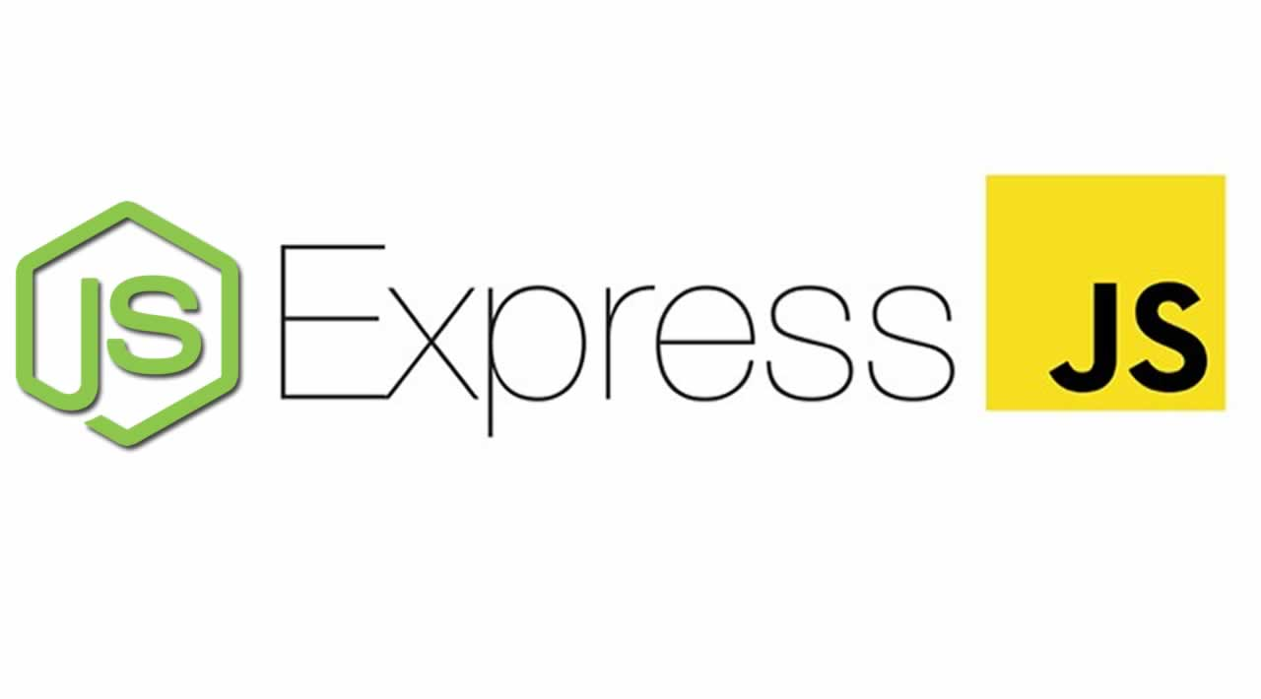

Figure 6: Express Framework

Due to some different architecture with REST, GraphQL developer is provided other express framework version called express-graphql. It support GraphQL HTTP server connect styled middleware.

2.4.3 ReactJS

React as a JavaScript library developed by Facebook for building UIs. It cannot be denied the popular of React in many website applications due to its SPA feature. Based on data changes, just the right components will be updated and render effectively.

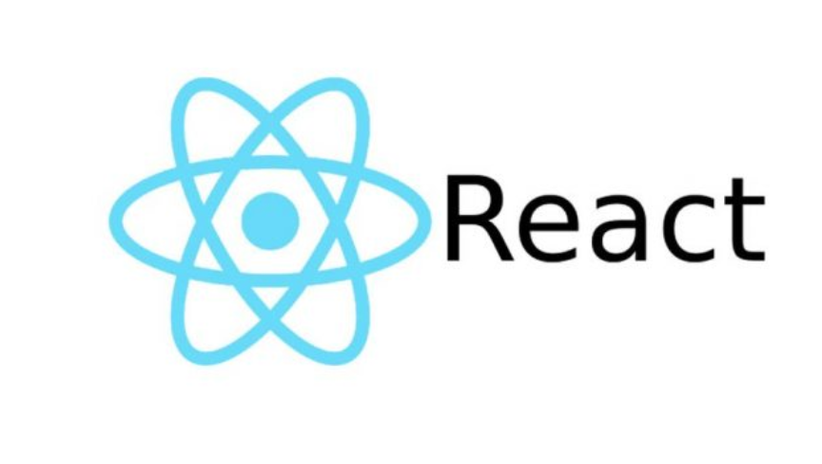

Figure 7 React Icon

Moreover, ReactJS code is quite clean, it normally predictable and easier for us to debug. It abstracts away the DOM, simplifies programming model and better performance.

2.4.4 Node.js

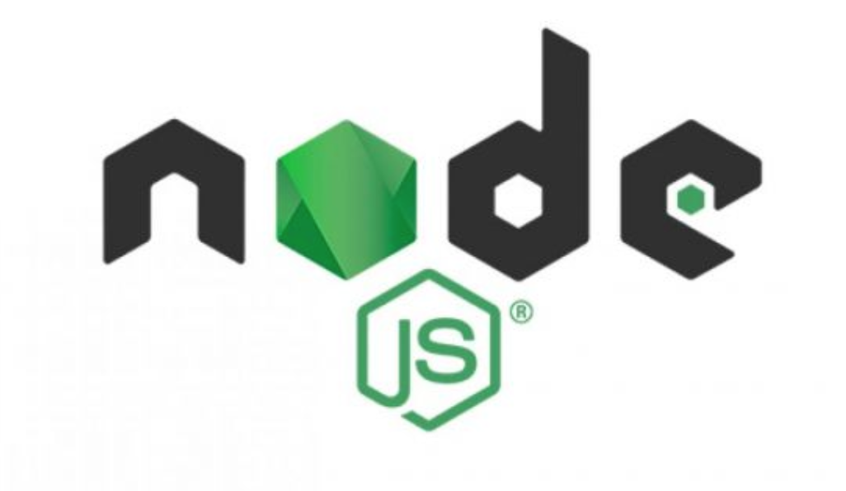

Figure 8 Node.js Icon

It is no double about Node.js, a JavaScript-based platform, built on Google V8 JavaScript. It used to develop non-blocking I/O API and asynchronous web application like SPA, video streaming, etc…Thanks to I/O model, real time, asynchronous, faster, scalable are the noticeable points of Node.js.

2.5 Other Technologies

2.5.1 Apollo

Apollo is a platform which is used to build, query and control a data graph. It is a centre gate way to permit applications communicate between clients and backend services. Additionally, It uses GraphQL to build and enforce the data flow pattern.

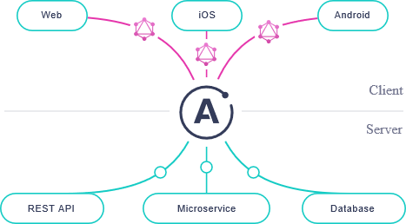

Figure 9 Workflow Apollo

It is noticed that GraphQL can be actually built without Apollo platform, there are many available libraries for GraphQL in the npmjs package but those libraries are not flexible, need to be customized for specified task and make code less clean. Moreover, some GraphQL platform are same as Apollo like Relay, urql,… However, Apollo is not only powerful, flexible but also easy-to-understand.

2.5.1.1 Apollo Server

Apollo Server is an open source GraphQL server by using JavaScript. It is one of GraphQL server libraries being fast, simple and built on top of Express.js This service can connect to data source from backend and work with data. Besides, it can be compatible with other GraphQL clients. Apollo Server are possibly used as an independent GraphQL server or add-on to existing application Node.js middleware (express, Fastify). This provides:

Straightforward setup: fast fetching data

Incremental adoption: Adding essential features

Universal compatibility: with other API.

Production readiness: shipping features quickly

2.5.1.2 Apollo Client

Apollo Client is a JavaScript library concerns state management which enables to control both local and remote data with GraphQL. This service is production-ready and can fetch, cache, modify data but UI still keep auto update. The core Apollo client was built to integrate with React. Especially, its syntax based on React Hooks.

2.5.2 JSON Web Token (JWT)

JWT, an open standard (RFC 7519), describes the way of information may be transmitted as a compact JSON object. It commonly used for authorization to securely protect API. In this project, we require a valid access token to be sent in the Authorization header of each request. The structure of JWT consists of three distinct parts divided by dots(.):

Header: containing token type and use the Algorithm to sign the token

Payload: having claims about an entity and additional data. These statement either have predefined claims (registered) or can be defined by JWT user (public/private claims).

Signature: to verify nothing changes during the transmission of token by hashing header, payload and a secret key declared.

The output is three Base64-URL strings and use dot(.) to concat these strings.

A JWT will look like this:

eyJhbGciOiJIUzI1NiIsInR5cCI6IkpXVCJ9*.eyJ1c2VySWQiOiI1ZmQwYWNmMDdlNT.*L6mXymNKGMP9xsE3WPvYKP9BClXDdPsFtHIQfkvCoQU

All of the information inside can be decoded again.

# CHAPTER 3 METHODOLOGY

3.1 Functional Requirement

Those functions are essentially implemented in the frontend to make client more interactive listed below.

|  |  |  |
| --- | --- | --- |
| Role | Function | Description |
| Guest | Register | Registering a new account to become member of web application |
| Login | Login allows users can use some private functions |
| Viewing list of flatmates,  flatmate detail | Everyone can visit the website and view the background information of flatmate. |
| Viewing list of houses, household detail | Everyone can visit the website and view the background information of household |
| Using search function | To find the ideal flatmate or household by choosing specified values on search tool. |
| User | Logout | Exit of system. Return guest view |
| Updating the personal information | User can edit their personal information |
| Chat message | User can chat with other ones for discussion. |
| Creating new household | Creating new house to display on Household view page |
| House Owner | Updating the information of house | Owner can edit their household information |
| Admin | Dashboard | Visualize data chart, analyze user behaviors |
| Remove User/ Household | Delete User or Household |

Table 1 The description of function implemented in the application

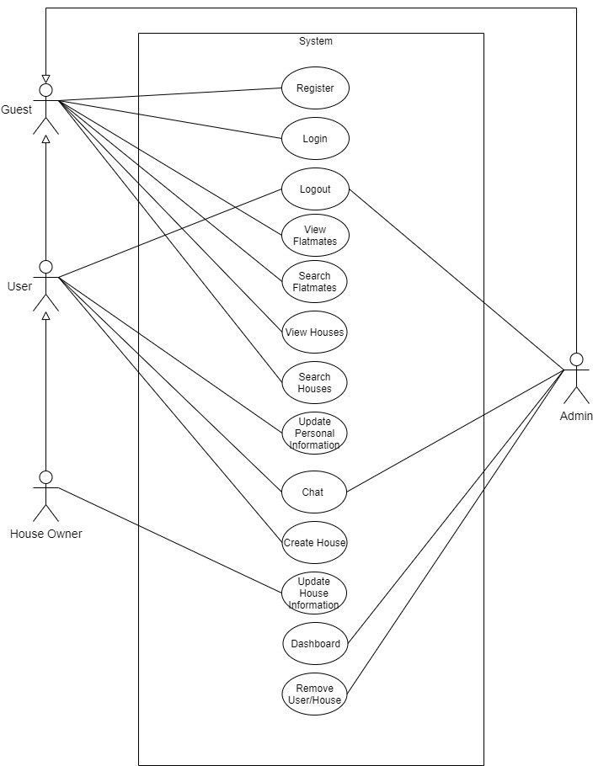

Figure 10 The use case diagram of share accommodation application

# CHAPTER 4 SYSTEM DESIGN

This system architecture is inspired by the first GraphQL architecture in Chapter 2. A greenfield project means that there no integrate with existing systems. This system is a GraphQL server with a connected database.

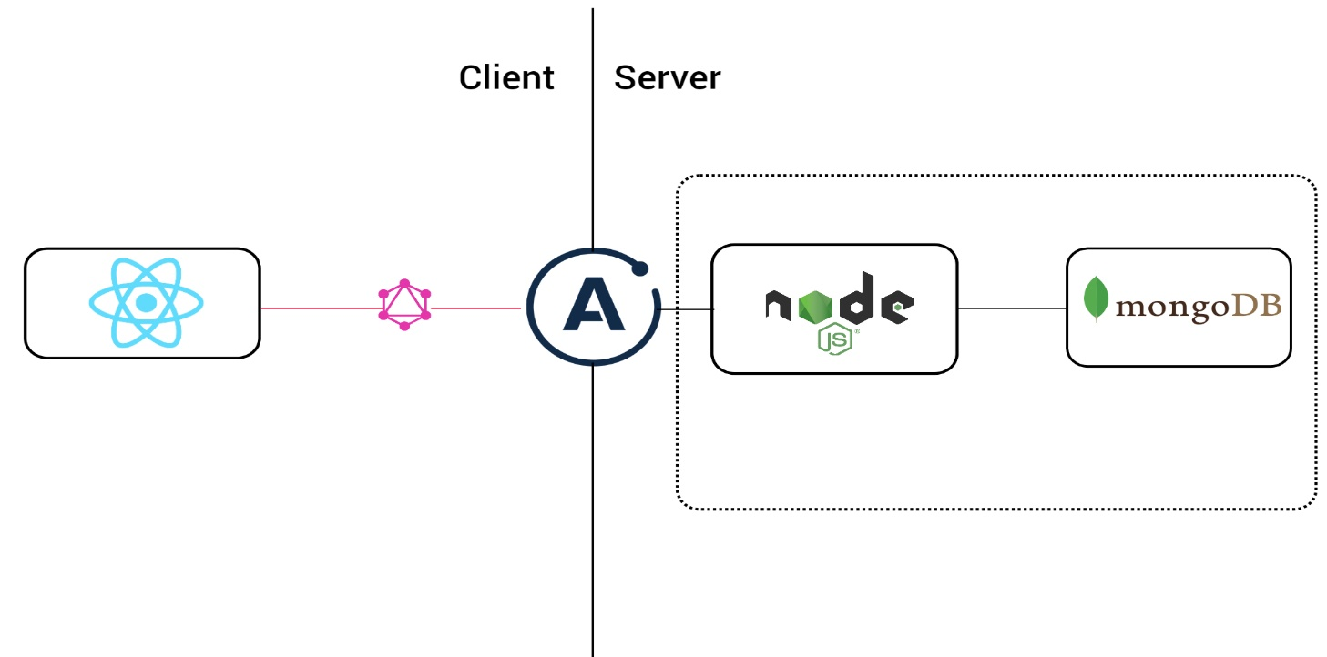

Figure 11 the system design of the web app

4.1 How the system work

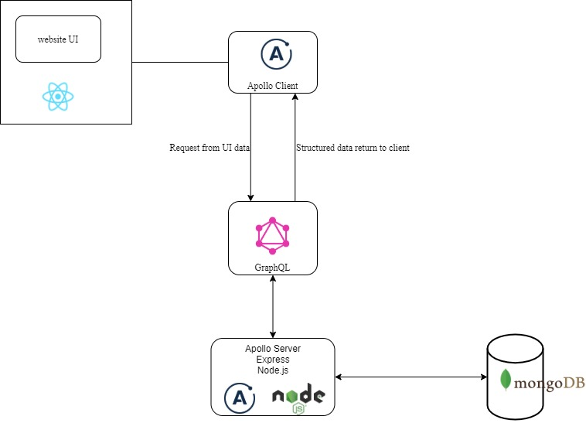

Figure 12 The communication of system

Apollo client is used to serve the interface between client UI and the server. When used with React, its functions similarly as the Redux store provider. As can be seen from the Figure 12, ReactJS library is used for building UI. Users can use actions on the browser to send request to server, however, the request is handled by Apollo client before arriving the server. Apollo server sits between client and database, it is responsible for listening requests from the client. Then, this server makes some requests to database, and passes back normalize data.

4.2 Frontend client

4.2.1 React Core Architecture

4.2.1.1 Virtual DOM and Real DOM

DOM stands for Document Object Model, which is very vital for modern interactive web app. However, one of DOM weakness is that components in the tree structure of DOM are changed even if they do not need to do it. That means some unnecessary updates are not required but still conduct the actions by default. In case of big project with a huge amount of views or doing frequent changes to the data model, it will cause terrible issues. To overcome this problem, the virtual DOM is created to track the changes of events. In the fact that, the virtual DOM was copied from the real DOM with some customizations so that it also has been similarity properties of the real DOM. Nevertheless, it cannot directly make any changes to the view. DOM manipulation is quite slow process in contrast with virtual DOM manipulation. the virtual one is faster than real one since its actions do not affect to the UI.

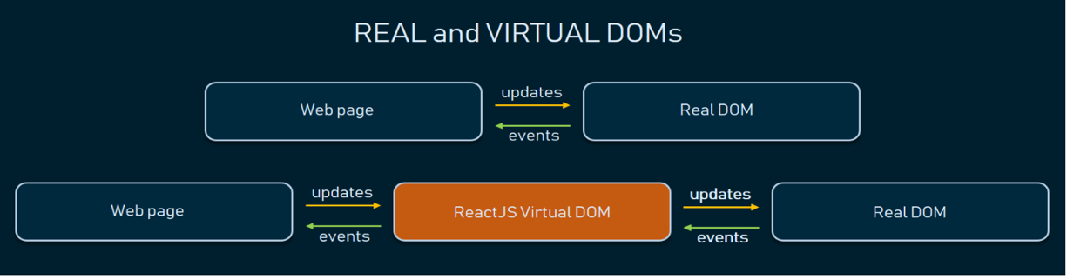

Figure 13 the contrast of real and virtual DOMs

4.2.1.2 Reusable Components

Another powerful feature of React brings to developer is that the ability to design small, self-contained components that can be flexibly reused over the application. As a heart of React, each React app is a collection of components. Components let the UI to be split into small pieces, those small components are nested inside one another and display data to the view and update automatically. Components are same as JavaScript functions, the same task can be performed in different environment or different approaches. As well as functions, they can get data from other sources called props and passes back React elements. The entire interface or small part are able to be built by components and combined together.

4.2.1.3 React Hooks

React Hooks was released at the beginning of 2019 for resolving a wide variety of problems in React. Due to the dramatic growth of HOC (high order component), render prop, drilling drop or mixins that design pattern lead to code become complex and difficult in writing, improving, maintaining or testing. Instead of using inheritance, Hooks use composition to improve the growth experience that allows share logic among components, dynamical mixins. There are several noticeable problems solved by using Hooks.

* + Wrapper hell (from the patterns: HOC, render prop, drilling prop).
  + Huge components (hard to test, maintain and co-locate code)
  + Confusing classes (reusable problem)

Generally, React Hooks are special functions that permit state and lifecycle methods exist together in functional components. They take argument and pass back the value. Besides, developer can be also easily custom hooks by their styles.

4.2.2 Apollo Client

Apollo Client is a great data management library for JavaScript that allows to update, modify and cache data in web app as well as fetching data from GraphQL APIs. Its architecture is unidirectional data flow like the Flux one. This library has a single source of truth called Apollo Client Cache which is used to store all results received from the queries. By this way, this service prevents sending requests multiple times for the same data. The data will be normalized by the Apollo Client Cache, the cache APIs to update state, and auto broadcast changes to queries the whole app as state changes.

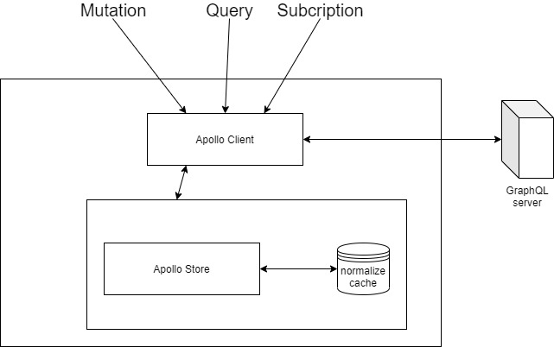

Figure 14 The architecture of Apollo client

The figure illustrates where the cached data is stored from its data store by Apollo Client. Each mutation is observed by the client to compare data from the backend with data already in the store and if any changes the cached data will be updated.

The primary Apollo Client library is designed to integrate with React. Especially, all syntax based on React Hooks.

4.2.2.1 Queries

Queries are operations that fetch data without side-effect. Apollo Client provide the ‘*useQuery*’ React hook for executing queries in an Apollo App. as component renders, ‘useQuery’ return an object which contains *loading, error, and data* properties to handle with UI.

4.2.2.2 Mutation

With ‘*useMutation’* hook we can send updates to the GraphQL server. It is the core API for doing mutations in Apollo app. As component renders, ‘useMutation’ will return a tuble that includes:

* + A mutate function to execute the mutation, and it can be called at any time.
  + An object that contain details about the current state of the mutation’s executation

4.2.3 Apollo Server/Node.js

Apollo Server is a powerful featured GraphQL server. It is based on Express.js and other libraries to build production-ready GraphQL servers.

There are some considerable features:

* + - GraphQL spec-compliant
    - Realtime feature with type Subscription of GraphQL
    - GraphQL playground
    - Extensible by Express middlewares.
    - Resolving custom directives Schema
    - Tracing query performance

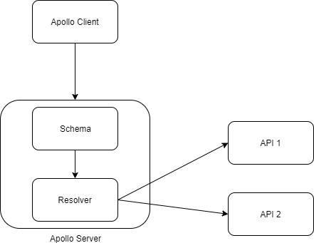

Figure 15 The architecture of server

The diagram illustrates how to the backend server-side work. Apollo server is a layer between client and database/API.

A GraphQL schema is required defined first to represent the structure of data graph. It’s very important because schema decides exactly which queries and mutations are available for client to talk with our graph.

Resolvers is a function used to help the server know how to write data for each field in schema. Then, the server can respond to request for arrived data such as fetching data from the backend database. Also, it is defined in the Schema.

4.5 Requirement Analysis

This part provides a database for the share accommodation application.

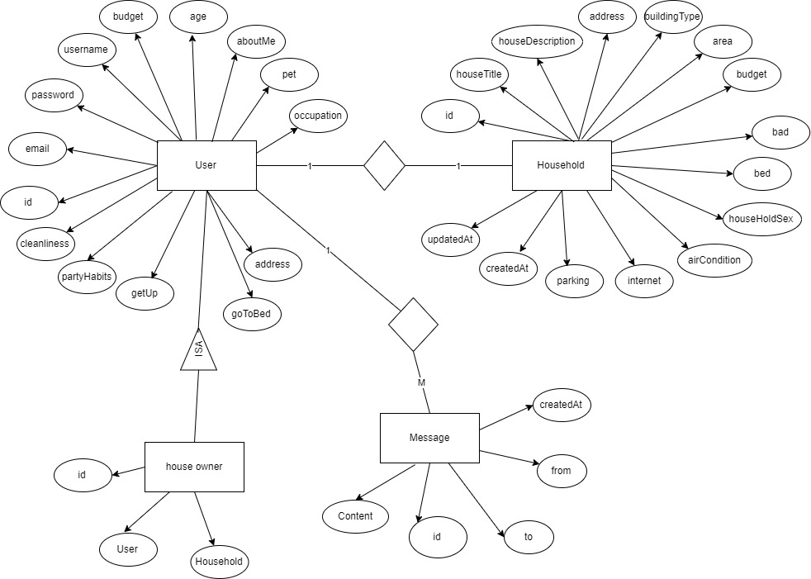

Figure 16 ERD diagram

4.6 Sequence Diagram

Each sequence diagram below demonstrates the work flow of each function in the system.

* Login and logout function

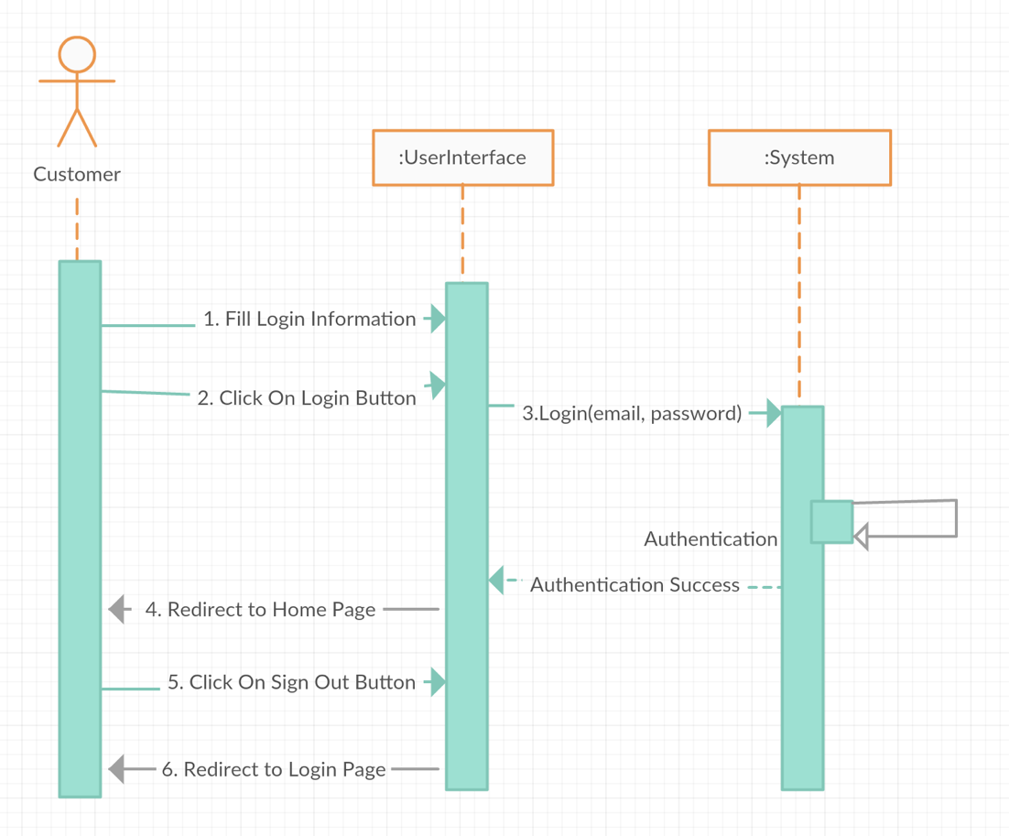

Figure 17 login and logout function in sequence diagram

* Register function

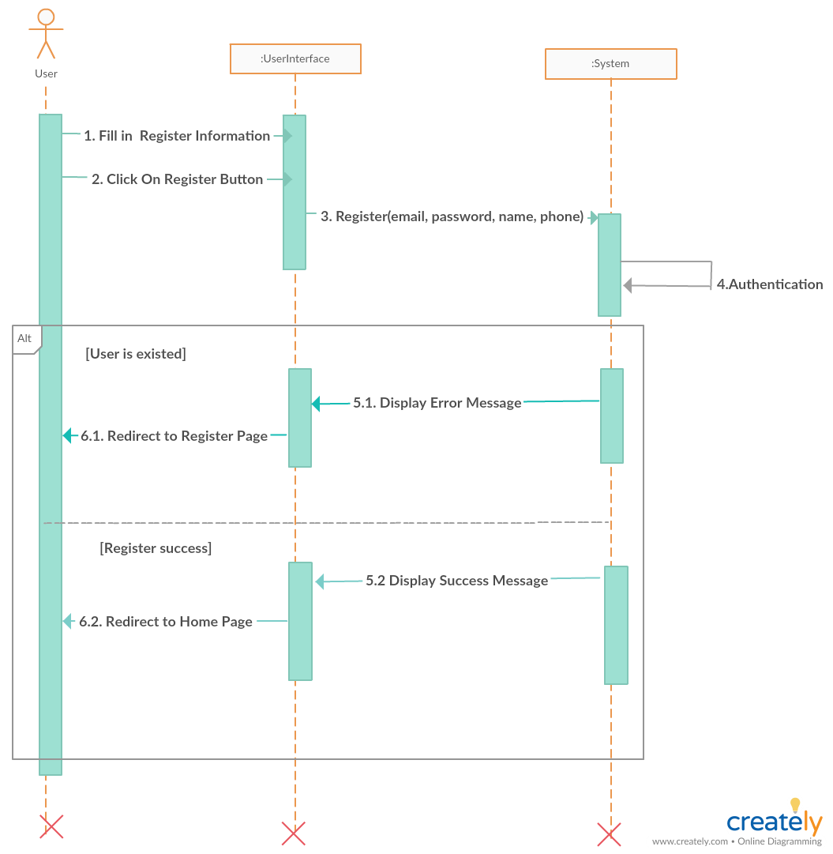

Figure 18 Register Account sequence diagram

* Update user’s information

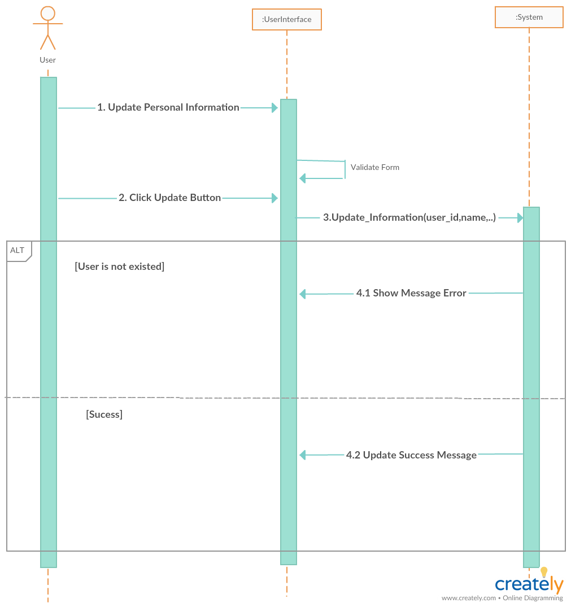

Figure 19 Updating personal information sequence diagram

* Creating new household

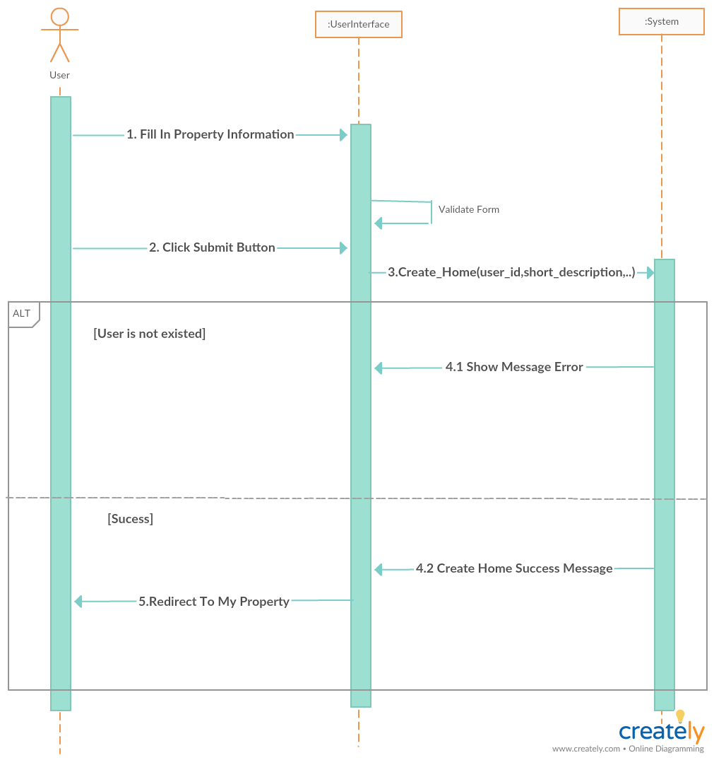

Figure 20 creating new household sequence diagram

* Updating household information

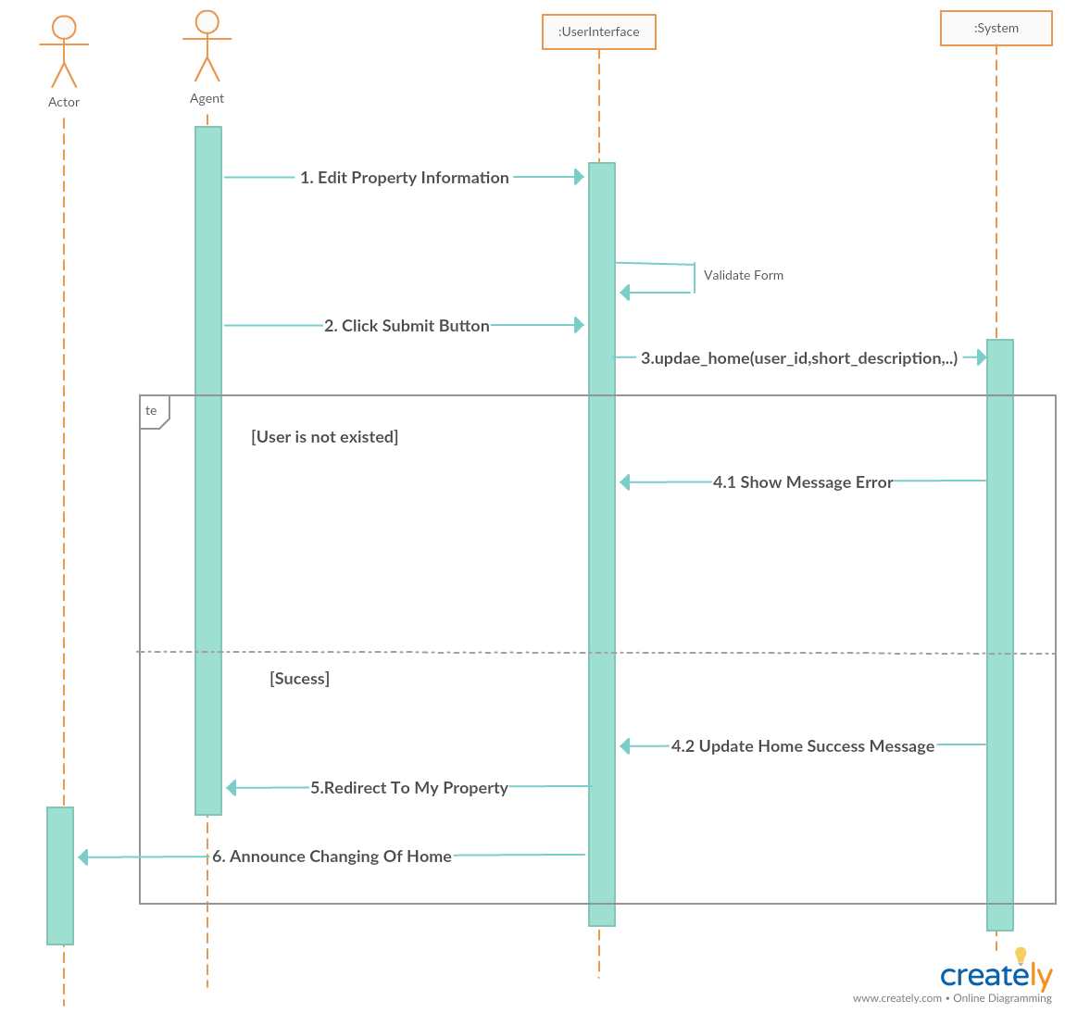

Figure 21 Updating household information

* Search Function for Flatmate Page and Household Page

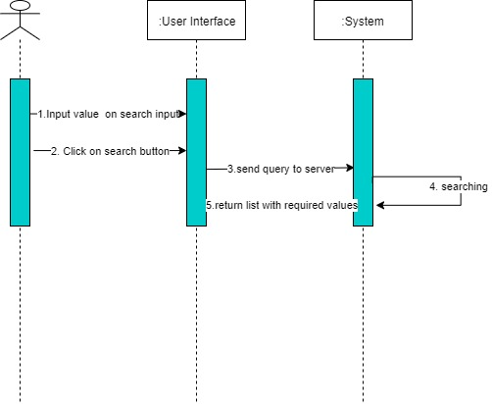

Figure 22 searching flatmate/household sequence diagram

# CHAPTER 5 IMPLEMENTATION

After having an overview about this thesis project. This chapter will focus on build the final product, and it is also a significantly part because it contains a huge of methods of coding and releasing system.

5.1 Setup technologies

For lots of technologies above, this part will guide to set up the initial background for technologies

5.1.1 Node.js and Express